**CTF Challenge: Windows Security**



**What is Windows Security?**



Windows Security, formerly known as Windows Defender, is the built-in antivirus and antimalware program included with all modern versions of Microsoft Windows. It acts as your system's first line of defense against various cyber threats like viruses, malware, spyware, and other malicious software.

Here's a breakdown of Windows Security's features and functionalities:

* **Real-time Protection:** Windows Security continuously monitors your system for suspicious activity in the background. It scans files, applications, and websites you access in real-time, blocking potential threats before they can infect your device.
* **Virus and Threat Protection:** This core functionality includes:
  + Malware scanning: Detects and removes malicious software like viruses, worms, and Trojan horses.
  + Spyware protection: Identifies and blocks spyware programs that steal your personal information.
  + Tamper protection: Protects your security settings from unauthorized modifications.
* **Cloud-based Protection:** Windows Security leverages cloud intelligence to stay updated on the latest threats and provide real-time protection against emerging malware variants.
* **Firewall and Network Protection:** This feature helps monitor incoming and outgoing network traffic, filtering out potential threats and unauthorized connections.

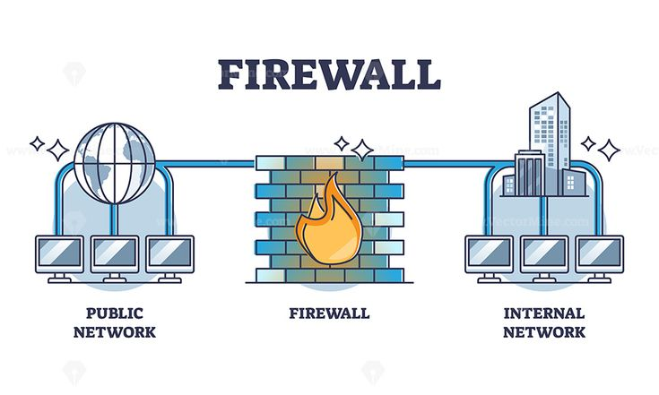

# **Capture the Flag (CTF) Challenges**

Flag 1. What is the former name of Windows Security?

Answer: Defender

Flag Captured

Flag 2. Security continuously monitors the system for suspicious activity in the background.

Answer: Real-Time Protection

Flag Captured

Flag 3. Detects and removes malicious software like viruses, worms, and Trojan horses

Answer:Malware Scanning

Flag Captured

Flag 4. What helps Cloud-based protection Windows Security stay updated on the latest?

Answer: Threats

Flag Captured

Flag 5. Besides virus protection, Windows Security can also act as a what?

Answer: Firewall

Flag Captured